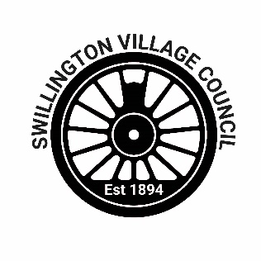
Swillington Village Council

Grant Scheme Application Form

Name of group:
Main group contact:
(full name and title)
Position in group
Address
Telephone
E-mail
Provide a detailed description of the project and who will benefit from it
Say how you know there is a need for your project
What are the full costs of the project (including VAT if applicable)
Where is other funding from the project to come from? (Tell us the funder and the amount you expect from them) | Funder ………………………………………………… £……  Funder ………………………………………………… £……  Funder ………………………………………………… £……
Please tell us the stage at which your other applications are at, ie just applied, awaiting outcome of application or funding confirmed.

What contribution to these costs would you like from the village council? | £ ……………………..
Why do you need a contribution to costs and what made you decide to approach the Village Council?
Is this contribution for a specific element of the project?

What is the structure of your organisation? | Informal group □  Registered charity □  Other □ Please give details below  ………………………………………………………………………
Please sign in the box to the right to confirm all information you have provided is truthful and that you have read and accepted Swillington Village Council’s grant scheme terms

Supporting information checklist

Please ensure that the following information is submitted with your application.

Tick to confirm enclosure
Evidence of actual or estimated expenditure (e.g. invoices or quotes received)
Evidence of planning permission (if necessary)

Please return to:

Swillington Village Council Clerk
clerk@swillingtonvillagecouncil.gov.uk

