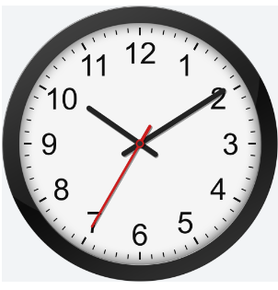
OPENING HOURS
SWILLINGTON HEALTH PRACTICE
MONDAY | 8.00 am - 5.30 pm
TUESDAY | 8.00 am - 5.30 pm
WEDNESDAY | 8.00 am - 5.30 pm
THURSDAY | 8.00 am - 5.30 pm
FRIDAY | 8.00 am - 5.30 pm
ROTHWELL MARSH STREET
MONDAY | 8.00 am - 6.00 pm | Urgent Assessment Clinic  Please register at Reception 8.00am – 9.30am
TUESDAY | 7.00 am - 6.00 pm
WEDNESDAY | 8.00 am - 6.00 pm | Urgent Assessment Clinic  Please register at Reception 8.00am – 9.30am
THURSDAY | 8.00 am - 6.00 pm
FRIDAY | 8.00 am - 6.00 pm | Urgent Assessment Clinic  Please register at Reception 8.00am – 9.30am

OULTON MEDICAL CENTRE
MONDAY | 8.00 am - 8.00 pm  5.00 pm – 7.30 pm - Family Planning Clinic | Urgent Assessment Clinic  Please register at Reception 8.00am – 9.30am
TUESDAY | 8.00 am - 6.00 pm | Urgent Assessment Clinic  Please register at Reception 8.00am – 9.30am
WEDNESDAY | 8.00 am - 6.00 pm
THURSDAY | 8.00 am - 6.00 pm | Urgent Assessment Clinic  Please register at Reception 8.00am – 9.30am
FRIDAY | 7.00 am - 6.00 pm

